  ICAPE  International |  |  |  | Customer Name: Valentinea
 |  |  |  | Customer P/N: SI945D
 |  | Note I: Please declare your technical questions with simple, clear, logic and professional sentence in English.  Note II: Please kindly check the following technical questions item by item and reply within a working day |  | Supplier P/N: 042113084A0
Question |  |  | Suggestion |  | Client Reply
2 | See this picture below, the plated holes are larger than copper PADs and without any net connection on bottom side only, but they have normal copper pads on top side.  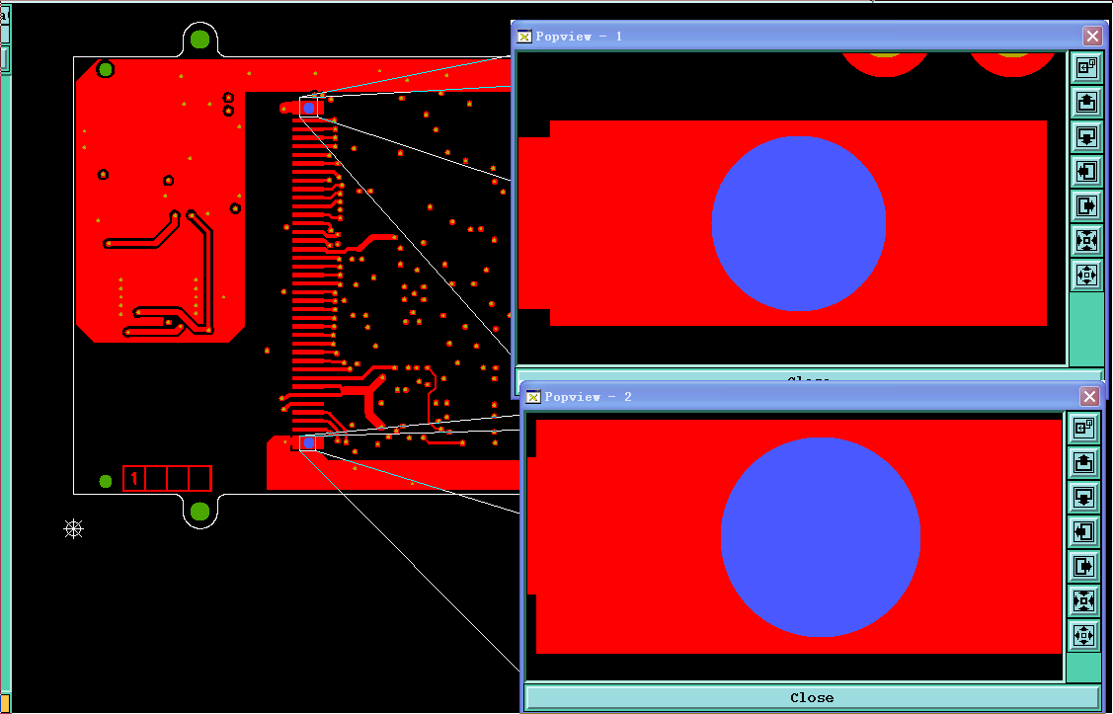--→top side  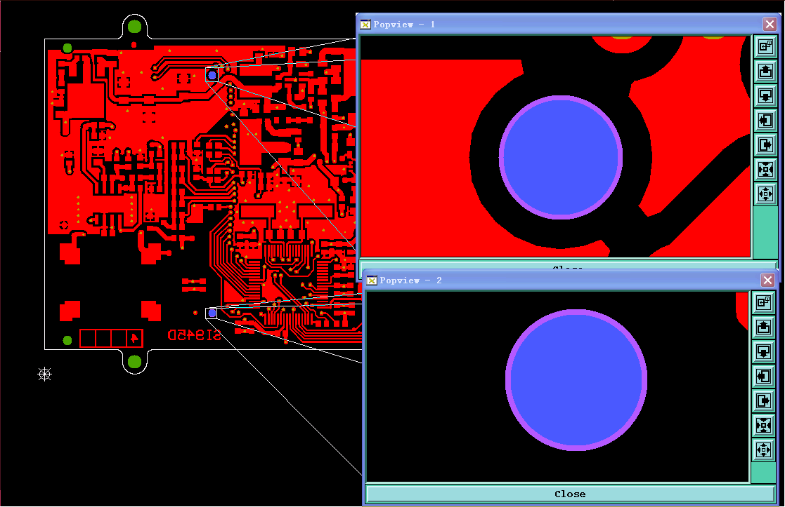→bottom side |  | We will do it for plated holes without pad ring on bottom side.  Please confirm. |  | The top plated hole should be connected to the ground plane on the bottom side like on the previous version of the board :  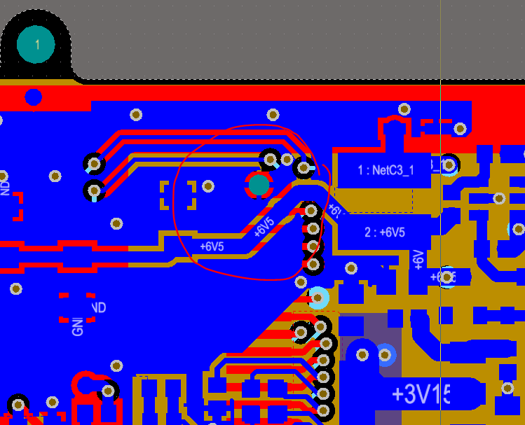  What do you suggest?
2-2nd | As you can see above picture, for such holes, there is only copper pad larger than hole on top side, according to you reply, we should add copper on ground layer 1, 2 and bottom layer, so that the hole is interconnected. |  | Please confirm our suggestion or you would update Gerber file? |  | After check, please don't modify the gerber. It's OK if the pins are not linked to ground.  So use your first suggestion : " We will do it for plated holes without pad ring on bottom side.  "
7 | We received your panel design requirement, and we make a panel drawing attached for your approval. |  | Please check attached our panel drawing and confirm if it’s ok? |  | See attached files.
7-2nd | Per you attached file, see below image, you revised the panel that the right unit PCB in the panel should be view as top side, and left unit in panel is bottom side with rotate 180 degree, right?  Also, do you want to use only one stencil for top and bottom SMT assemble?  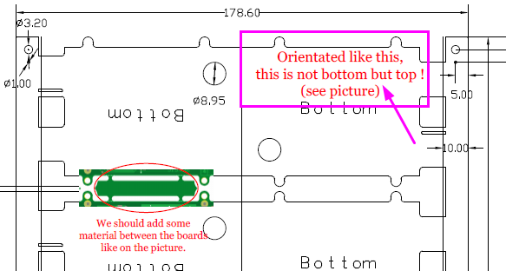 |  | Please confirm our question!  Please help to provide us original solder paste file. |  | The left and right PCB must all show there bottom side.  Please refer to the picture joined with this email and do the same.

Supplier: Checked by: | Henry Date:  2016-12-21 |  |  | Customer:  Approved by: | Date:

